## Lab 1: Insert a data in 3rd position of existing array.

## Output:

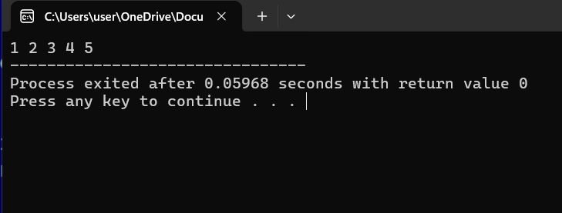

## Lab 2: Find the Product of odd position and sum of even positions of an array

## Output:

## 

## Lab 3: Show Sequential/Linear Search using iterative approach.

## Output:

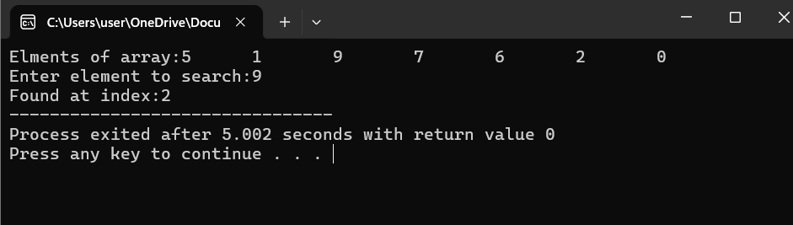

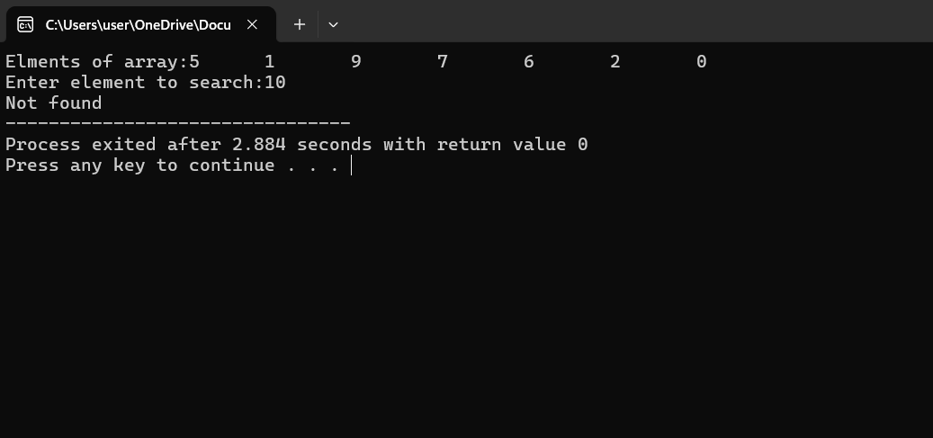

## Lab 4: Show Binary Search

## Output:

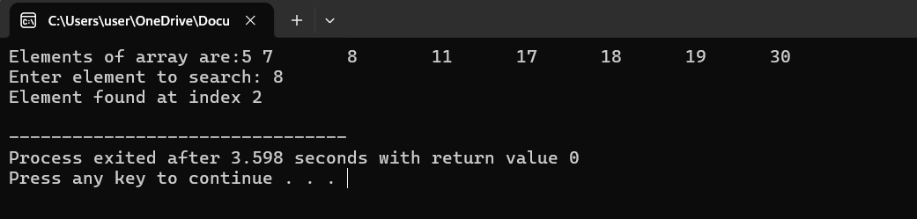

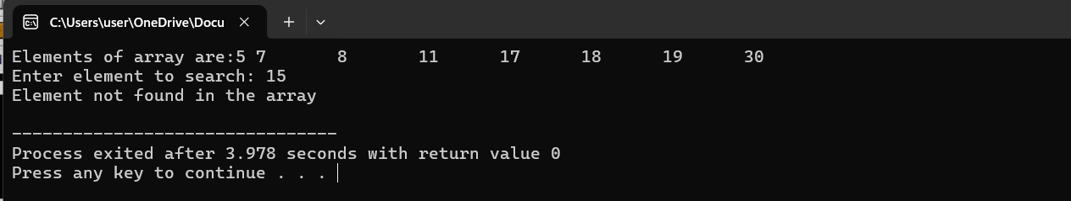

## Lab 5: Operation of a linked list(create, insert, search, delete)

## Output:

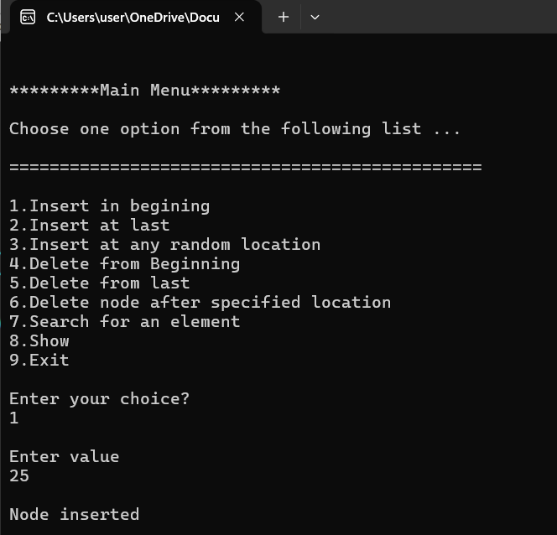

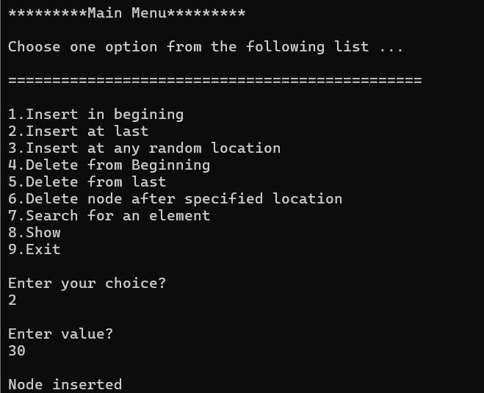

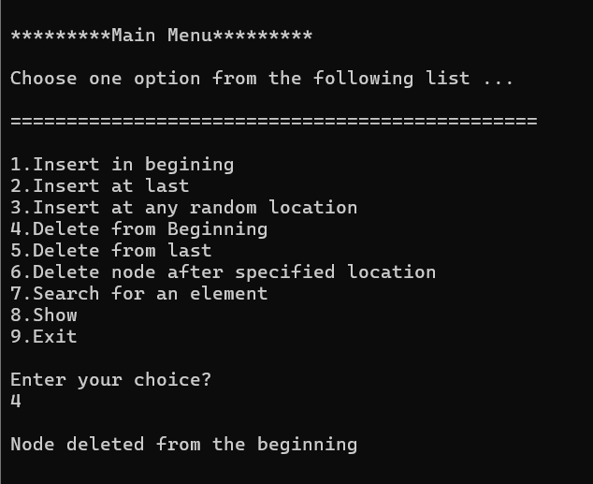

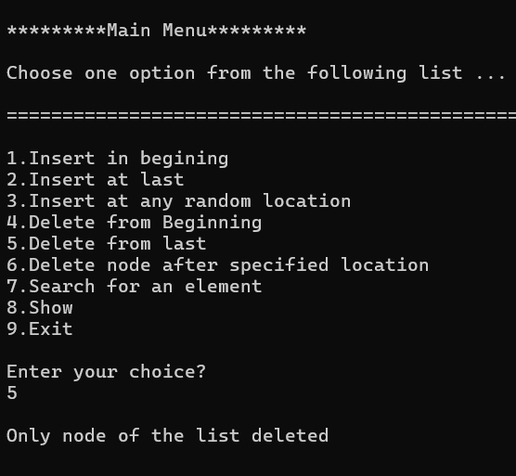

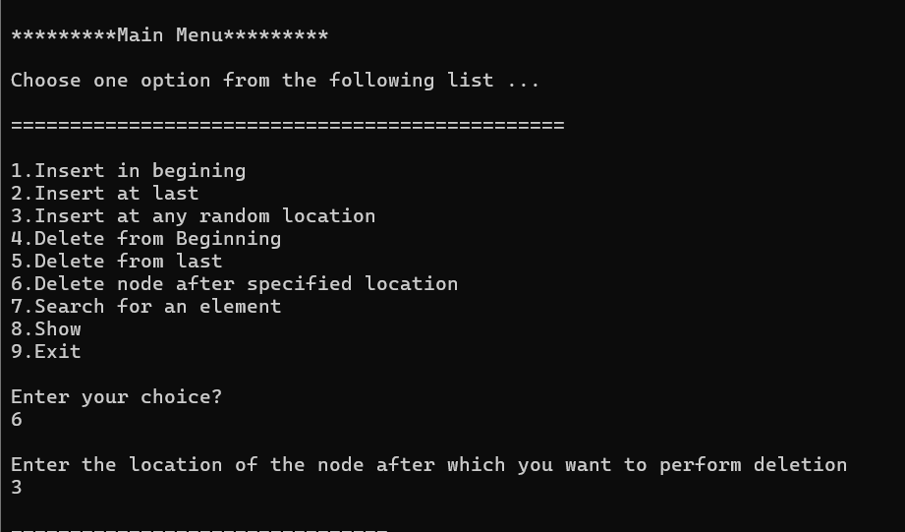

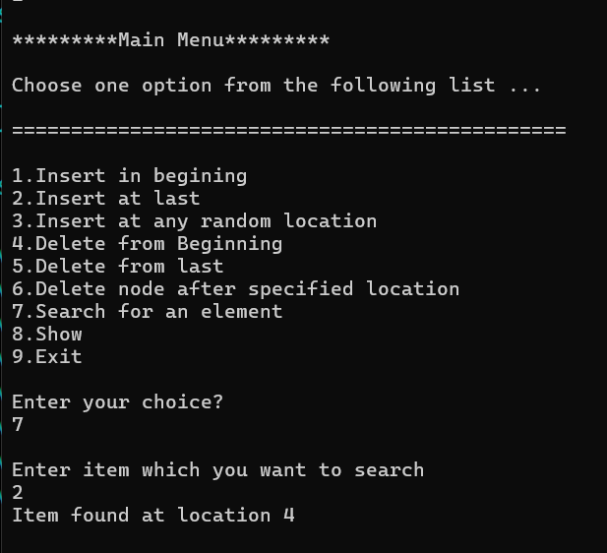

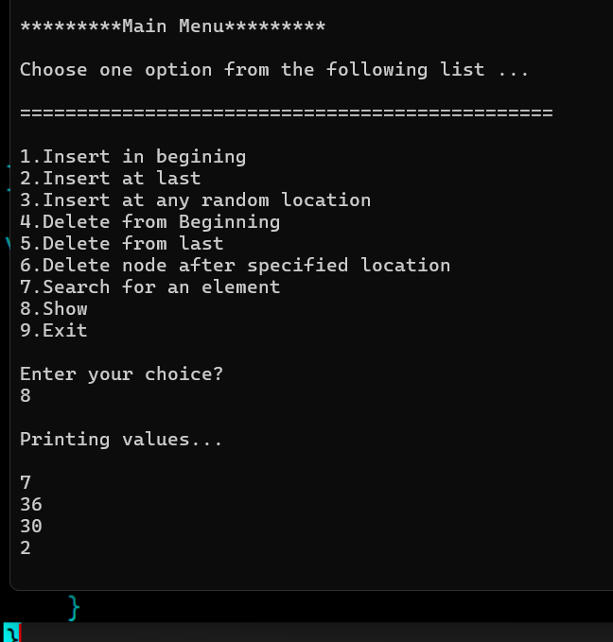

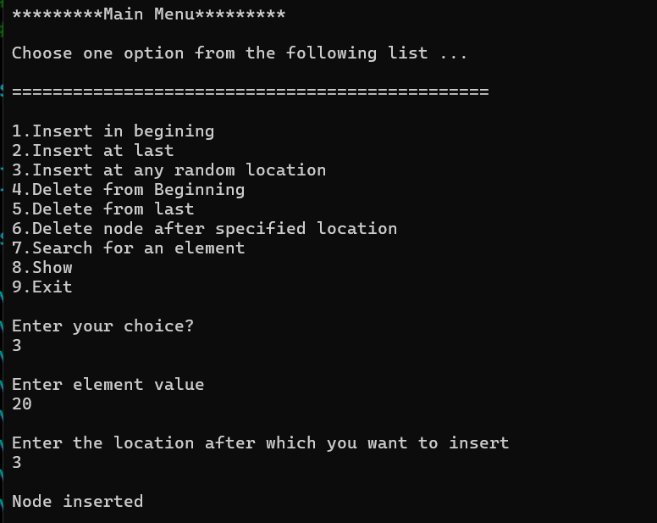

## Lab 6: Stack Functions

## Output:

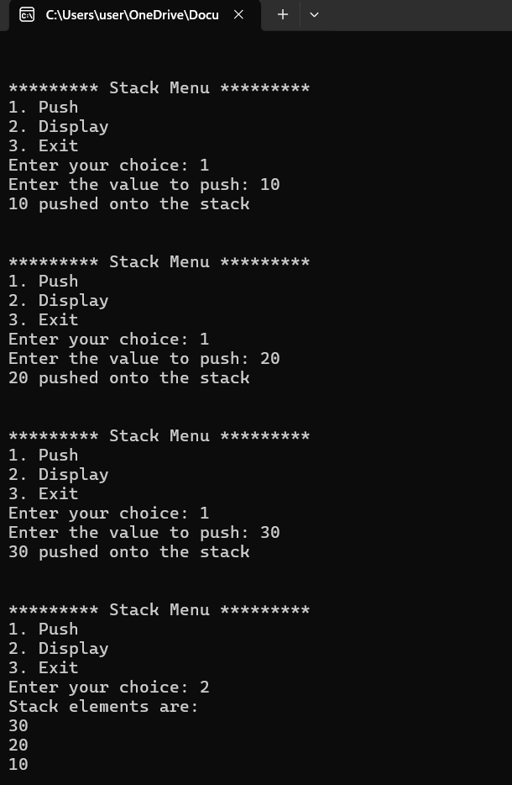

# Lab 7: Queue Functions

## Output:

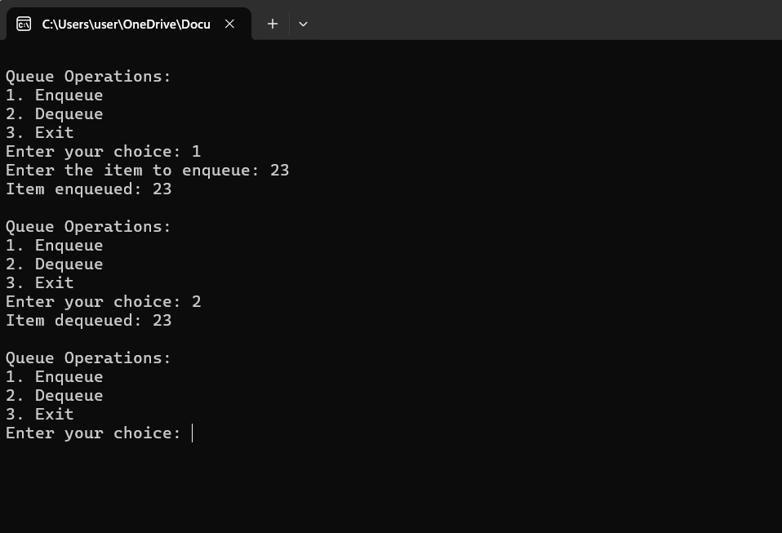

## Lab 8: Find the factorial of a number using recursion.

## Output:

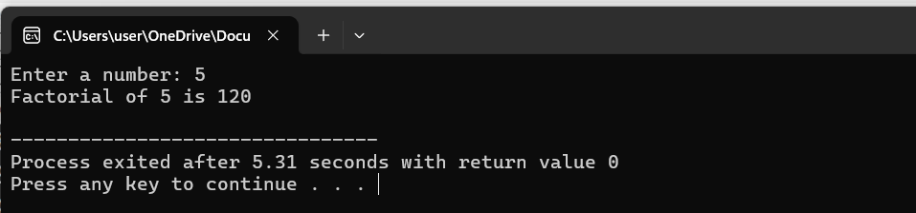

## Lab 9: Find the Fibonacci Series using recursion.

## Output:

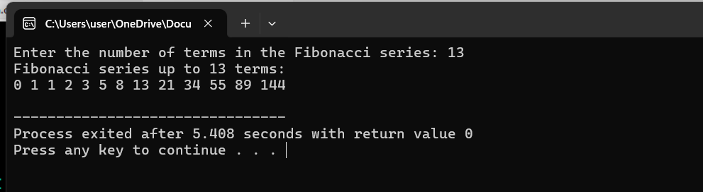

## **Lab 10: Find the GCD (Greatest Common Divisor) using recursion**.

## Output:

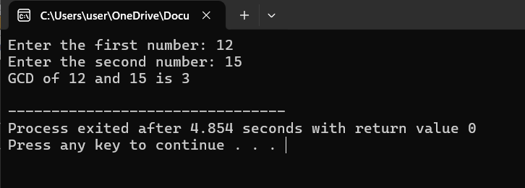

## Lab 11: Tower of Hanoi using recursion.

## Output:

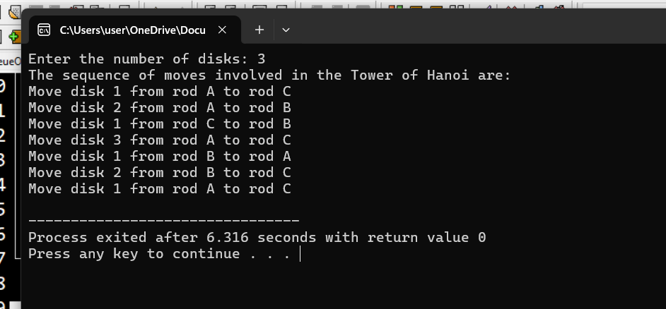

## Lab 12: Bubble Sort (Iterative Approach)

## Output:

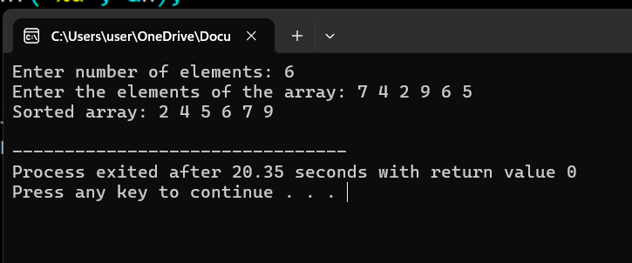

## Lab 13: Selection Sort (Iterative Approach)

## Output:

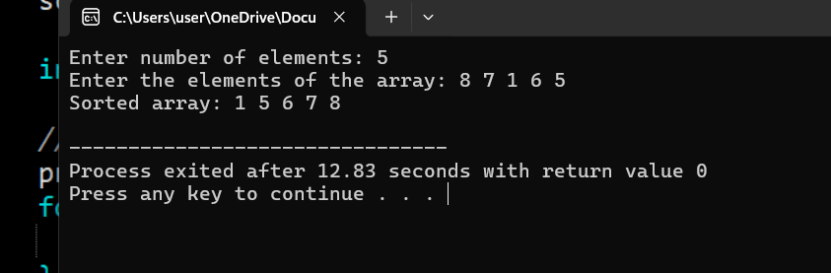

## Lab 14: Insertion Sort (Iterative Approach)

## Output:

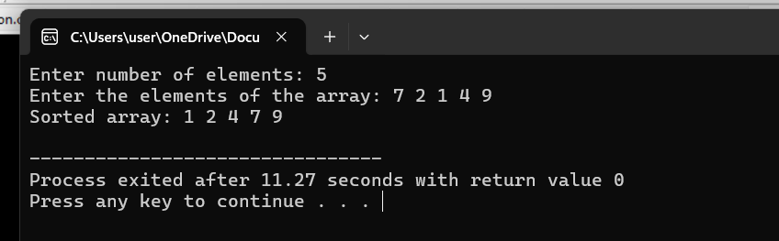

## Lab 15: Quick Sort (Divide and Conquer Approach)

## Output:

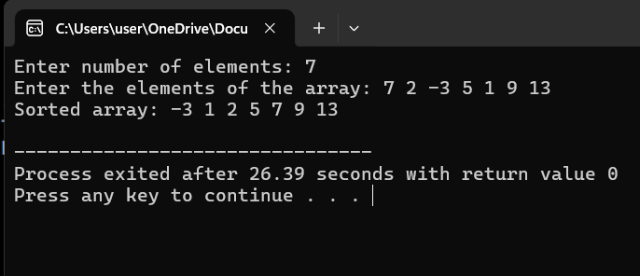

## Lab 16: Merge Sort (Divide and Conquer Approach)

## Output:

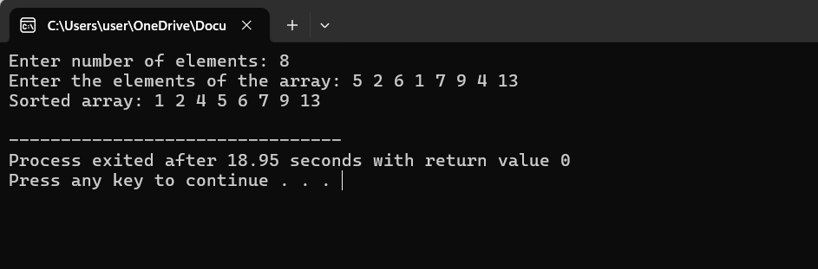

## Lab 17: Radix Sort (Upto thousands)

## Output:

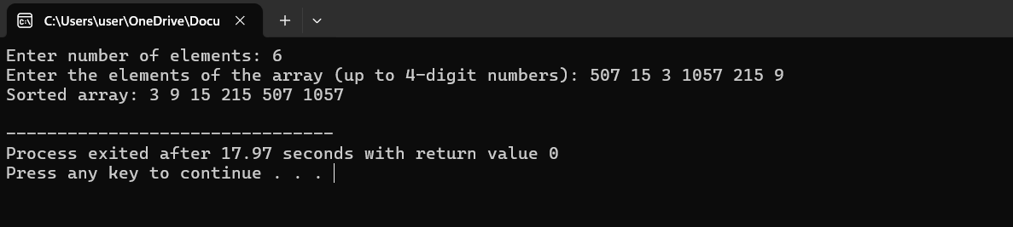

## Lab 18: List Operations

## Output:

